A000-Asia-China-Hongshan-Eagles-Jade-3500-2200 BCE

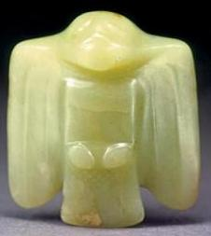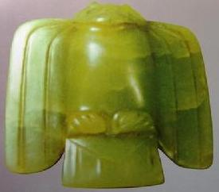

Figs. 1-2. Figs. 1-2 Hongshan-Eagles-Jade-3500-2200 BCE.

**Case No.: 5**

**Accession No.**

**Formal Label:** Hongshan-Eagles-Jade-3500-2200 BCE.

**Display Description:**

These two birds, probably eagles with wings swept back are represented in a frontal, prey pursuing posture, and reveal a Hongshan conception of an aviary type of carnivorous creature. The adeptness of the hunting bird of prey was also found ensconced in clay-molded fragmentary birds in the Goddess Temple where two bird claws were found in a votary context indicating some form of bird **worship** along with some bear related fragments, and these may have been the fragmentary parts of one or more so-called dragon bodies.

**Accession Number:**

**LC Classification:**

**Date or Time Horizon:**

**Geographical Area:**

**Map:**

**GPS coordinates:**

**Cultural Affiliation:**

**Media:**

**Dimensions:**

**Weight:**

**Condition:**

**Provenance:**

**Discussion:**

**References:**